Software test report

OpenCart

Prepared By: Kamil Khalaileh

Contents

Quality Status 2

Test Environments Covered 2

Defects by functional area 2

List of Existing Defects 2

Defects by Severity 2

# Quality Status

The quality of the OpenCart Ecommerce website is better than previous versions. In this version, there are still important issues that need to be fixed and hence we ‘**Do not Recommend this version for release’**.

# Test Environments Covered

We have tested the web application in the below environments:

* Windows 10 – Chrome
* Windows 10 – FireFox
* Windows 10 – Edge

# Defects by functional area

Below is the statistics of the existing defects by functional area:

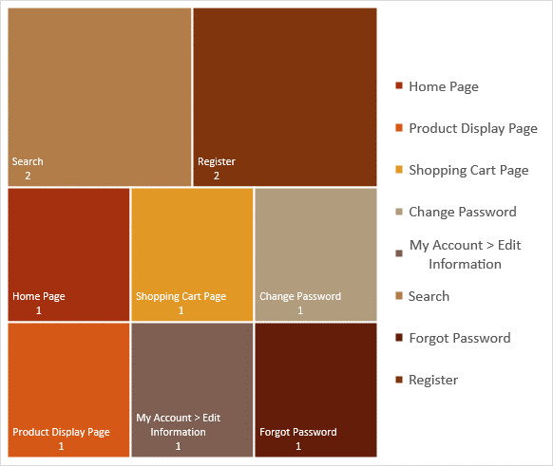

# Defects by Severity

# List of Existing Defects

|  |  |  |
| --- | --- | --- |
| **Issue ID** | **Summary** | **Severity** |
| OP-10 | Home Page - Hovering next to product carousel edge leads to visual error | Low |
| OP-9 | Product Display Page - Adding a negative quantity to cart displays success message | Medium |
| OP-8 | Shopping Cart Page - Updating quantity with special characters deletes the item | Low |
| OP-7 | My Account Change Password - Password change can exceed 20 characters | Low |
| OP-6 | My Account Edit Information - First and Last name allow special characters | Low |
| OP-5 | Search - Empty category search returns no results | Low |
| OP-4 | Search - Empty search doesn't return all results | Low |
| OP-3 | Forgot Password - Password reset link is not sent to email | High |
| OP-2 | Register - Confirmation email is not sent on new user signup | High |
| OP-1 | Register - There is no validation for Telephone field | Low |